|  |  |
| --- | --- |
| **Computer Science 1** | **Lab 09A**  **Open Ended Major Python Project** |
| **The Modular Graphics Project** | **90, 100, 110 and 0 Point Versions** |
| **Assignment Purpose:**  This program requires knowledge of modular programming and reviews graphics. | |

You need to create an original graphics program similar to the output below.

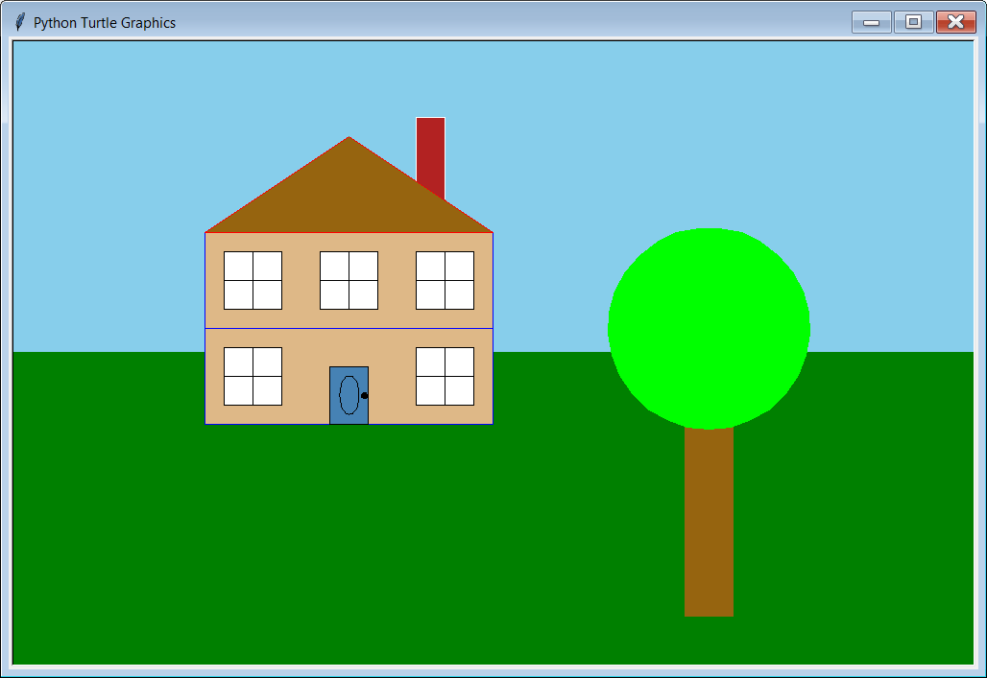

NOTE: You may NOT draw this or any other house!

Your graphics program must be something original that YOU create. The program should consist of several procedures (no less than 4) similar to program examples **GraphicsProcedures04.py**, **GraphicsProcedures05.py**, **GraphicsProcedures08.py**, **Library02.py** or **Library03.py**. Your graphics program must show a considerable amount of effort. It also must be school appropriate!

**NOTE: This project requires the use of “Traditional Graphics” which was introduced in Chapter 6! You may not do this assignment using “Turtle Graphics” or “ASCII Text Graphics”.**

**90 Point Version**

The “**MAIN**” section of the program calls several user-defined procedures, similar to program example **GraphicsProcedures04.py** (or **GraphicsProcedures05.py** or **GraphicsProcedures08.py**).

There needs to be a minimum of 4 user-defined procedures.

The entire program is contained in the **Lab09Ast.py** file.

**100 Point Version**

The “**MAIN**” section of the program calls several user-defined procedures, which are imported from a separate *library* file which you need to create. The file **Lab09Ast.py** will only contains the following:

* 2 **import** statements (one for **Graphics**, the other for the library that you create)
* 1 **beginGrfx** statement and 1 **endGrfx** statement
* several procedure calls (minimum of 4)

All procedure definitions need to be placed in your library file, similar to the organization of program example **Library02**. Make sure this file is also saved in the **Lab09A-ModularGraphicsProject** folder.

**110 Point Version**

The “**MAIN**” section of the program calls several user-defined procedures, which are imported from multiple separate *library* files, all of which you need to create. The file **Lab09Ast.py** will only contain the following:

* Multiple **import** statements (one for **Graphics**, the others for the libraries that you create)
* 1 **beginGrfx** statement and 1 **endGrfx** statement
* several procedure calls (minimum of 6)

All procedure definitions need to be logically placed in your different library files, similar to the organization of program example **Library03**. Make sure that all library files are also saved in the **Lab09A-ModularGraphicsProject** folder.

**0 Point Version**

You will earn a 0 on this major project if any of the following are true:

* Your program is not school appropriate.
* Your program does not show sufficient effort.
* Your program is a house
* Your program uses “Turtle Graphics” or “ASCII Text Graphics”.
* Your program has all of the graphics commands in the “**MAIN**” section of the program,

similar to **GraphicsProcedures03.py**, missing the whole point of the lab(MOST COMMON).